



Orbital Implant Information Sheet.

2 Witney Way,
Boldon Business Park,
Boldon, Tyne and Wear.
NE35 9PE.
Comments, queries or orders please contact Altomed on:
Tel: (0) 191 519 0111
Fax: (0) 191 519 0283

IMPORTANT: Only suitably trained and qualified

0120
surgeons should carry out this procedure under normal

Do not
re-sterilise
operating room conditions.

The function of an implant is to replace lost orbital volume, provide a motility-enhancing anterior attachment site for the extra ocular muscles, and preserve the structures of the orbit. The implant can be used by following standard enucleation or evisceration procedures as trained. These devices are supplied sterile and are ready for use. They can be used with a suitable wrapping material if required, e.g. vicryl, sclera etc.

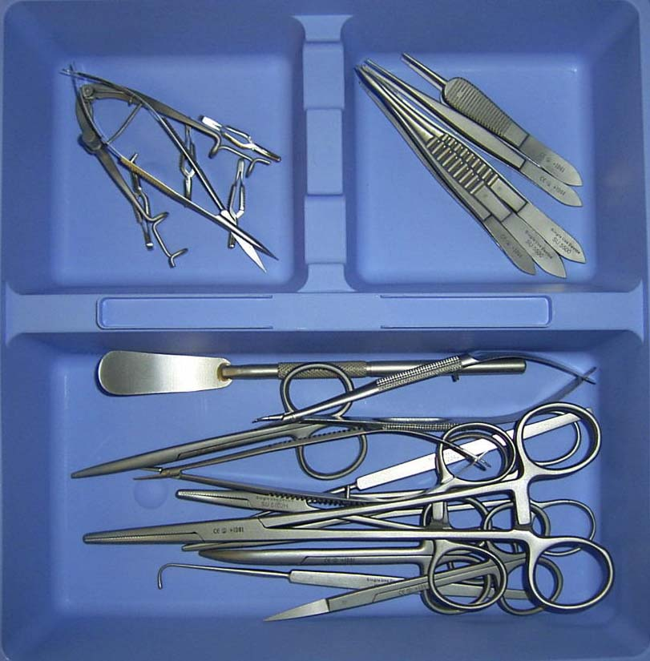
Code | Product Description
A7084 | Acrylic (Lucite) Sphere 12mm Sterile
A7086 | Acrylic (Lucite) Sphere 14mm Sterile
A7088 | Acrylic (Lucite) Sphere 16mm Sterile
A7092 | Acrylic (Lucite) Sphere 18mm Sterile
A7094 | Acrylic (Lucite) Sphere 20mm Sterile
A7100 | Silicone Sphere 10mm Sterile
A7102 | Silicone Sphere 12mm Sterile
A7104 | Silicone Sphere 14mm Sterile
A7106 | Silicone Sphere 16mm Sterile
A7108 | Silicone Sphere 18mm Sterile
A7110 | Silicone Sphere 20mm Sterile
A7112 | Silicone Sphere 22mm Sterile
Complimentary Equipment:

Silicone or acrylic conformers
are also available from Altomed
Limited in sizes Small, Medium
and Large.

Altomed Limited now also supply
a Sterile Single Use Enucleation
Instrument Set Ref: SUS100
Feedback on these products is welcomed in order to maintain post market surveillance procedures
Form ALT I012 – Issue 03/0409

Orbital Implant Information Sheet.

2 Witney Way,
Boldon Business Park,
Boldon, Tyne and Wear.
NE35 9PE.
Comments, queries or orders please contact Altomed on:
Tel: (0) 191 519 0111
Fax: (0) 191 519 0283
IMPORTANT: Only suitably trained and qualified

0120
surgeons should carry out this procedure under normal

Do not
re-sterilise
operating room conditions.

The function of an implant is to replace lost orbital volume, provide a motility-enhancing anterior attachment site for the extra ocular muscles, and preserve the structures of the orbit. The implant can be used by following standard enucleation or evisceration procedures as trained. These devices are supplied sterile and are ready for use. They can be used with a suitable wrapping material if required, e.g. vicryl, sclera etc.

Code | Product Description
A7084 | Acrylic (Lucite) Sphere 12mm Sterile
A7086 | Acrylic (Lucite) Sphere 14mm Sterile
A7088 | Acrylic (Lucite) Sphere 16mm Sterile
A7092 | Acrylic (Lucite) Sphere 18mm Sterile
A7094 | Acrylic (Lucite) Sphere 20mm Sterile
A7100 | Silicone Sphere 10mm Sterile
A7102 | Silicone Sphere 12mm Sterile
A7104 | Silicone Sphere 14mm Sterile
A7106 | Silicone Sphere 16mm Sterile
A7108 | Silicone Sphere 18mm Sterile
A7110 | Silicone Sphere 20mm Sterile
A7112 | Silicone Sphere 22mm Sterile
Complimentary Equipment:

Silicone or acrylic conformers
are also available from Altomed
Limited in sizes Small, Medium
and Large.

Altomed Limited now also supply
a Sterile Single Use Enucleation
Instrument Set Ref: SUS100
Feedback on these products is welcomed in order to maintain post market surveillance procedures
Form ALT I012 – Issue 03/0409

