




Orbital Implant Information Sheet.

2 Witney Way,
Boldon Business Park,
Boldon, Tyne and Wear.
NE35 9PE.
Comments, queries or orders please contact Altomed on:
Tel: (0) 191 519 0111
Fax: (0) 191 519 0283

IMPORTANT: Only suitably trained and qualified

0120
surgeons should carry out this procedure under normal

Do not
re-sterilize
operating room conditions.

Intended Use:
The function of an implant is to replace lost orbital volume, provide a motility-enhancing anterior attachment site for the extra ocular muscles, and preserve the structures of the orbit. The implant can be wrapped in a suitable material such as autogenous temporalis fascia, irradiated preserved fascia, preserved sclera, vicryl etc, or implanted unwrapped and the muscles sutured anteriorly. It is normally used in evisceration or enucleation procedures. The device should be implanted in accordance with the surgeon’s standard procedures and training. It is important that the correct size of sphere is selected taking into account orbital tissue contraction and the risk of dehiscence; too small a sphere will not provide enough volume and too large may cause extrusion. Unfortunately these devices do not give the best motility to prosthesis.

Contra-Indications and Adverse Effects
There are complications with the use of orbital implants, but these are not limited to those supplied by Altomed. These in the main appear to be due to surgical complications or unsuitable surgical techniques or the type of wrapping material if any, and not necessarily to the product design or the raw materials used. It is important to select the correct size of implant; incorrect sizing may result in volume deficiencies or poor motility of the prosthesis. As with any operation the patient will undergo a period of discomfort. Examples of complications or issues with the use of the implants are:

- Sectioning of the posterior globe rather than the optic nerve, leaving ocular structures in the orbit, in such cases residual tissues should be identified and removed
- Sympathetic Ophthalmia
- Implant extrusion or exposure or migration resulting in tissue erosion or dehiscence, the smooth Lucite Spheres can migrate or displace over time, this can occur when the muscle detaches itself or when the Sphere is not wrapped.
- Socket cul-de-sacs contraction and infection
- Rejection of the implant in particular in children
- Intraoperative discovery of unsuspected intraocular tumour
- Lag in patient’s prosthesis
- Trauma from the actual surgery (including infection)
- Enophthalmos
- Deep/Superior sulcus deformity
- Lower lid malposition
- Contracted fornices
- Ptosis of the superior and inferior eyelid
- Sphere may migrate if Surgeon imbricates the ocular muscles over the sphere, if this occurs a Ptosis of the upper eyelid may cause problems
- Loss of tissue for pathological examination
- Tissue necrosis may also occur in some cases
- Other associated problems may include Blepharoptosis, Pseudoptosis, Entropian, Ecrtropian, Lower Lid Laxity, Conjunctival Deficiency, Extraocular Muscle Dysfunction, Anophthalmic Enophthalmos, Tear Insufficiency, Hemorrhage and Conjunctival Scarring

If in the event that an implant is rejected, there are additional procedures which can be carried out which also prove successful, These may include removing the implant altogether, or replacing it with a dermis fat graft. Ptosis caused by implant migration can be surgically repaired or removed. Superior sulcus deformity can be treated with Fasanella procedure followed by full thickness resection. Epithelial breakdown can also be treated with ointment.
Please report any adverse events, complications or other side effects to the Quality Manager at Altomed.

Post Operative Care:
The Surgeon should monitor the patient at regular intervals as they deem necessary. For enucleation; it is important that a conformer or temporary prosthesis is used after enucleation to prevent contracture of the socket. A pressure patch can be applied if there is difficulty in retaining the conformer. If necessary the lids can be sutured together using 4-0 or 5-0 nylon inter-marginal mattress sutures until any oedema has subsided. The Ocularist can usually custom fit a new prosthesis approximately 6 weeks after enucleation. The surgeon should then examine the patient with the prosthesis in place, this examination should note the:

- Centration of the implant
- Size and depth of the Fornices
- Socket motility with and without the prosthesis in place
- Position of the upper and lower lids
- Levator function
- Symmetry of the upper lid skin folds and Sulci

Any corrective eyelid surgery is usually deferred for several months, and any secondary socket reconstruction is usually not done for 6-12 months.
Postoperative care is the same as with enucleation, with the exception that the temporary Tarsorrhaphy is not released until the Ordema has subsided. This generally occurs 1-2 weeks postoperatively. If the cornea has been removed it may be difficult to close the scleral cavity over the implant without tension. Unless a small implant is used, it is necessary to open the Sclera posteriorly such that the anterior sclera can be closed without tension. Patient should be told not to rub or apply pressure to their eye.

Processing of non-sterile devices only:
These devices are normally supplied sterile and are ready for use; please note sterile devices should not be reprocessed. In the event you require a non-sterile device, the spheres can be cleaned in a 6 minute Ultrasonic wash of Ruhof Liquiclean H (or similar hospital approved detergent) followed by two thorough rinses in Milli-Ro grade water with drying in a laminar hood. The Lucite spheres should not be exposed to alcohol. The Silicone Spheres can be sterilized in the autoclave using a standard 134-137°C cycle with a 3 minute holding time, see HTM Guidance. The Lucite Spheres should not be processed in the autoclave as they will melt. They should be sterilized in Ethylene Oxide using a hospital approved and validated procedure, contact Altomed for processing parameters if required.
All processes must be carried out by suitably trained staff in a hospital approved controlled environment.
Complimentary Equipment:
Sterile Silicone or PMMA conformers and Symblepharon Rings are also available

A3710 | Symblepharon ring small
A3712 | Symblepharon ring medium
A3714 | Symblepharon ring large
A7122 | PMMA/Lucite conformer small
A7124 | PMMA/Lucite conformer medium
A7126 | PMMA/Lucite conformer large
A7130 | Silicone conformer small
A7132 | Silicone conformer medium
A7134 | Silicone conformer large

Device Disposal:
Devices should be disposed of following hospital approved procedures for contaminated waste.
NEW! Now Available:
Birmingham Snare A7067with detachable barrel for use by left or right handed
Surgeons, also makes it easier to load the snare wire.

Code Product Description

A7084 Lucite Sphere 12mm Sterile
A7086 Lucite Sphere 14mm Sterile
A7088 Lucite Sphere 16mm Sterile
A7092 Lucite Sphere 18mm Sterile
A7090 Lucite Sphere 19mm Sterile
A7094 Lucite Sphere 20mm Sterile
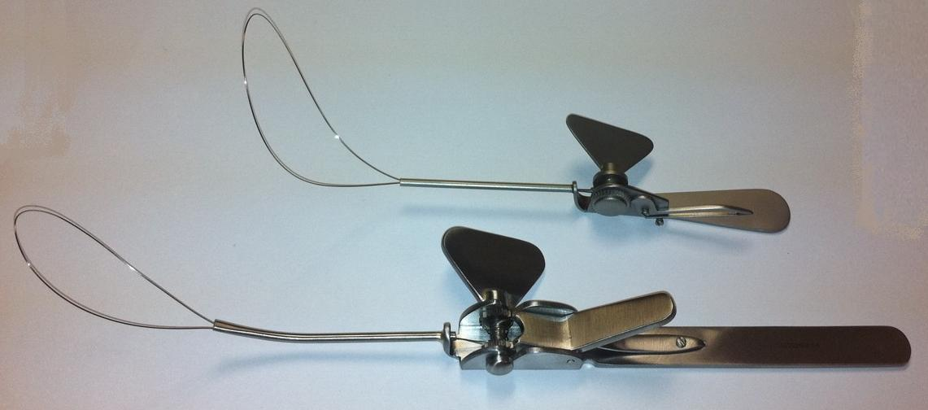
A7100 Silicone Sphere 10mm Sterile
A7102 Silicone Sphere 12mm Sterile
SU7066/1 Fosters Snare
A7067
Birmingham
Snare
A7103 Silicone Sphere 13mm Sterile
A7104 Silicone Sphere 14mm Sterile
A7105 Silicone Sphere 15mm Sterile
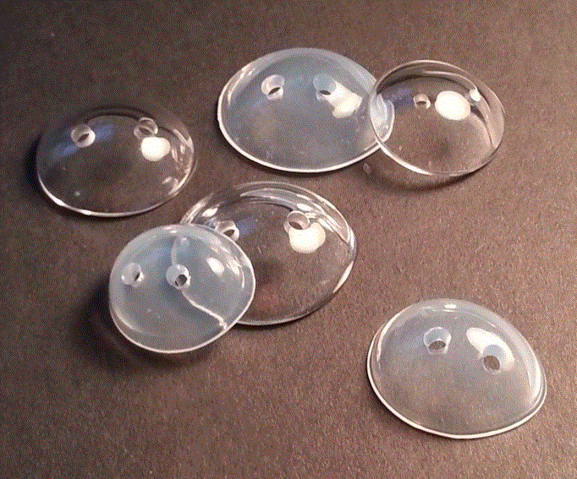
A7106 Silicone Sphere 16mm Sterile
A7107 Silicone Sphere 17mm Sterile
A7108 Silicone Sphere 18mm Sterile
A7109 Silicone Sphere 19mm Sterile
A7110 Silicone Sphere 20mm Sterile
A7111 Silicone Sphere 21mm Sterile
A7112 Silicone Sphere 22mm Sterile

